**Getting Started with Linux**



**Submission:**

• Deadline: Wednesday, September 13, 2023, 8:00 pm HKT.

• Submit this answer sheet via Canvas->Assignments->Tutorials->Tutorial 1.

**Questions**

**A sample Linux file system**

**Paths:**

The Linux directory structure is like a tree. The base of the Linux file system hierarchy begins at the **root**. Directories branch off the root, but everything starts at root.

More details here: <https://bit.ly/2kcbpB5>

* Root is /
* Paths separated by /

e.g.,

/home/hls/notes

/home/alex

In the example above, write the full path to the report directory: …………………………………………



**ls (list - directory listing)**

An option changes the behaviour of a command. The **ls** command can be used with several options. An example of an option that can be used with **ls** is -**l**.

Key in **ls -l**

Your screen should look similar to the screenshot below:

cctom2@ubt18a:~$ **ls -l**

**Lower-case letter l.**

total 8

drwx-----x 1 cctom2 grads 4096 Jan 9 13:34 **Windows**

drwx-----x 1 cctom2 grads 4096 Jan 9 13:40 **www**

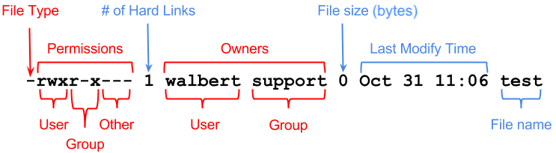

What effect does this option have? What are **ls -l** output columns? What is the size of each file in bytes for your output? ……………………………………………………………………………………………….…



**pwd** **(print working directory)**

The **pwd** command will show you the path to your current working directory. Unlike our ssh gateway server, some other Linux prompts may not show your working directory. So you can use **pwd** to find out where you are in the directory tree.

Type **pwd** command to view the path of the directory you are currently in.

This is your **current directory**. What is it? …………………………………………………………



**cd (change directory)**

# Exercise:

Change to the **root directory** using a single command. What command did you use?



…………………………………………………………………………………………

Change back to your **home directory**. Where your **home directory** is, will depend on what account you are logged in as. What is the full path of your home directory?



…………………………………………………………………………………………



**Exercise:**

1. Use **ls** to view all files in the **root** directory (/):



…………………………………………………………………………………………

2. Change to the */home* directory:



…………………………………………………………………………………………

3. Use **ls** to view all files in the */home* directory:



…………………………………………………………………………………………

4. What command would you use to go **directly** to your home directory from any other directory?



…………………………………………………………………………………………

5. Change back to the root directory



…………………………………………………………………………………………

**man (reference manual for getting help)**

To bring up help on a command, use the **man** command. For example to bring up help on the **ls** command

you wouldkey in the following:

cctom2@ubt18a:~$ **man ls**

Note: While you are in the help:

Pressing ***enter*** or down arrow key (↓) will allow you to scroll down through the text.

Pressing ***q*** will allow you to quit from the help.

What does the **-a** / **-l** (letter l) / **-1** (number 1) option do for the **ls** command?



…………………………………………………………………………………………



…………………………………………………………………………………………



What is the difference between the -g and -G options for the **ls** command?



…………………………………………………………………………………………



Some commands also provide a long option like **--help** to display usage help, e.g.,

**ls --help**

**Exercise:**

1. View the man page for the **mv** command.



…………………………………………………………………………………………



2. Display the usage help of the **mv** command.

…………………………………………………………………………………………



**mkdir (make directory)**

**Exercise:**

1. Create a new directory called reportFiles, in your home directory.



…………………………………………………………………………………………

2. Do a directory listing of your home directory.



…………………………………………………………………………………………

3. Create a file in the directory called reportFiles called operatingsystems.txt and write some texts to it.



…………………………………………………………………………………………

4. Do a directory listing of the reportFiles directory.



…………………………………………………………………………………………

5. Without changing to the **reportFiles** directory, create inside it a new directory called **backup**.



…………………………………………………………………………………………

6. Change into the **reportFiles** directory and check for yourself that the backup directory was created by your previous command.



…………………………………………………………………………………………



**cp (copy)**

**Exercise:** Try not to move from your home directory for each of the questions below.

Create a subdirectory in your home directory and call it **backup**.



…………………………………………………………………………………………

Copy **myfile.txt** into **backup**, keeping its original name.



…………………………………………………………………………………………



Copy **new.txt** into **backup** and call the destination file **new.bak**

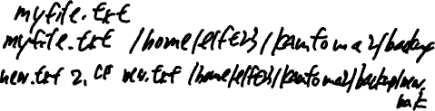

…………………………………………………………………………………………

Copy **new.bak** from the **backup** directory to your **current directory**.



…………………………………………………………………………………………



Create a directory called **letters** in your current working directory (home directory)



…………………………………………………………………………………………

Copy **new.bak** from the **backup** directory to **letters** directory and call the new file (the destination file) **new2.bak**



…………………………………………………………………………………………



**mv (move)**

**Exercise:**

1. Move the file **new.txt** into your **backup** directory.



…………………………………………………………………………………………

2. Without changing to the **backup** directory, move the file **new.txt** from the **backup** directory into your current working directory.



…………………………………………………………………………………………

3. Rename the file **new.bak** to **new2.txt**, using the **mv** command.



…………………………………………………………………………………………

**rm (remove)**

**Exercise:**

1. Delete the file new2.txt.



…………………………………………………………………………………………

Verify that it has been removed by issuing the **ls** command.

2. Delete the file in your backup directory called myfile.txt.



…………………………………………………………………………………………

3. Change directory to the backup directory and then delete the file myfile.txt in your home directory.



…………………………………………………………………………………………

4**.** Write the Linux command to delete the folder **backup** and its contents.



…………………………………………………………………………………………